

COUNTRY CLUSTERING
PROJECT
BUSINESS CASE
DATASET:
https://1drv.ms/x/c/a48c01fec5c3c6a6/IQDuwhfW9U- 9Qp2FOYpLtiJ_Adfen4dtPsiOS7YEAUqp4ho?e=6qRwTu

PROJECT STATEMENT

- Analyse country-level data using socio-economic and health indicators
- Identify patterns and similarities among countries
- Apply clustering techniques to group countries into meaningful segments
- Help an international NGO prioritize countries based on their needs
- Classify countries into categories like:
→ Underdeveloped
→ Developing
→ Developed
- Use data-driven insights to support better funding decisions
- Improve resource allocation for maximum impact

BUSINESS BACKGROUND
- An international NGO works with multiple countries worldwide
- The organization has limited funds and resources
- It aims to improve health, economy, and living conditions
- Not all countries need the same level of support
- Some countries are highly underdeveloped, while others are progressing
- The NGO needs a data-driven approach to identify priority countries
- The dataset provides key indicators like:
- → Income
- → Child mortality
- → Life expectancy
- → GDP
- By analysing this data, the NGO can focus on countries that need urgent help

BUSINESS UNDERSTANDING
- The NGO wants to identify countries that need support
- It faces limited funding and resources
- Not all countries require the same level of help
- Countries differ in:
→ Economic condition
→ Health standards
→ Social development
- The goal is to group similar countries together
- This helps in prioritizing underdeveloped countries
- Clustering is used because:
→ No predefined labels are available
→ It automatically groups similar countries
- The final aim is to:
→ Allocate funds effectively
→ Improve decision-making
→ Maximize impact of resources
FEATURES:
Country
→ Name of the country
Child mort
→ Child deaths per 1000 births
Exports
→ Exports as percentage of GDP
Health
→ Health spending as percentage of GDP
Imports
→ Imports as percentage of GDP
Income
→ Income per person (USD)
Inflation
→ Growth rate of economy (%)
Life_expec
→ Average life expectancy (years)
Total_fer
→ Average number of children per woman
GDPP
→ GDP per person (USD)

DATA UNDERSTANDING
- The dataset contains country-level information
- Each row represents one country
- Each column represents a specific indicator
- The dataset includes: → Economic indicators (income, gdpp, exports, imports, inflation)
- → Health indicators (child_mort, health, life_expec)
- → Social indicator (total_fer)
- Data is numerical, except the country column
- Values are in different scales (e.g., income vs percentages)
- Helps to understand development level of countries
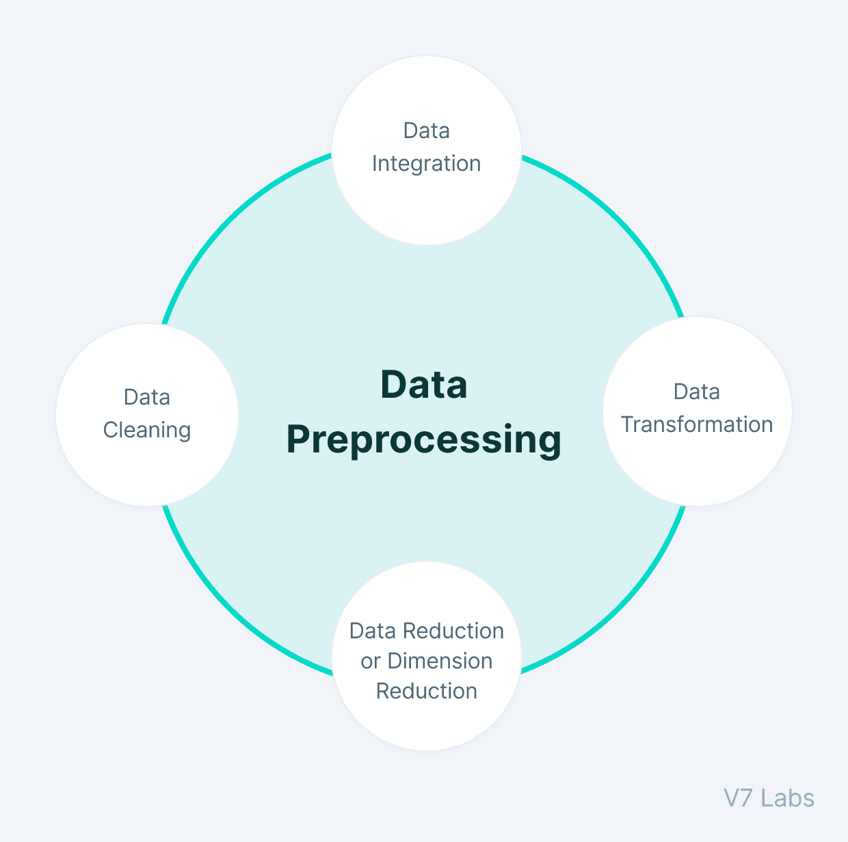
- No target variable → suitable for unsupervised learning (clustering)
- Load the dataset
→ Import the CSV file into Python using pandas
→ Helps to start analysis
- Check missing values
→ Identify if any data is missing (null values)
→ Missing data can affect results
- Check duplicates
→ Find repeated rows in the dataset
→ Remove duplicates to avoid incorrect analysis
- Drop non-numeric column (country)
→ Clustering works only on numbers
→ Country names are not useful for calculations
- Select important features
→ Use economic, health, and social indicators
Social indicators
health
economic

→ Helps in meaningful grouping
- Feature Scaling (StandardScaler)

Feature scaling
→ Convert all values to same scale
→ Prevent large values (income) from dominating

- Create final dataset for model
→ Use scaled data (X_scaled)
→ Ready for clustering algorithms

Why scaling is important?
- Different feature ranges
→ income, gdpp → very large values
→ health, exports → small values
- Clustering uses distance
→ Algorithms like K-Means measure similarity using distance
- Large values dominate
→ Features with bigger numbers control the result
→ Small features get ignored
- Scaling balances all features
→ Converts all values to the same range
- Improves clustering accuracy
→ Each feature contributes equally
- Better results
→ Proper grouping of countries
→ Meaningful clusters formed
EXPLORATORY DATA ANALYSIS (EDA) 

- Understand the Data
→ Analyse dataset structure, features, and values
- Check Data Distribution
→ Use histograms to see how values are spread
→ Example: income, child mortality, life expectancy
- Identify Outliers
→ Detect extreme values (very high or very low countries)
- Find Relationships
→ Observe how features are related
→ Example: income ↑ → life expectancy ↑
- Compare Indicators
→ Analyse economic, health, and social factors together
- Gain Insights
→ Understand differences between countries
→ Identify developed vs underdeveloped patterns

FEATURE SELECTION:
Select relevant features
→ Choose important indicators related to country development
Economic Features
→ income, gdpp, exports, imports, inflation
Health Features
→ child_mort, health, life_expec
Social Feature
→ total_fer

Remove irrelevant feature
→ Dropped country column (non-numeric, not useful for clustering)
ALGORITHMS
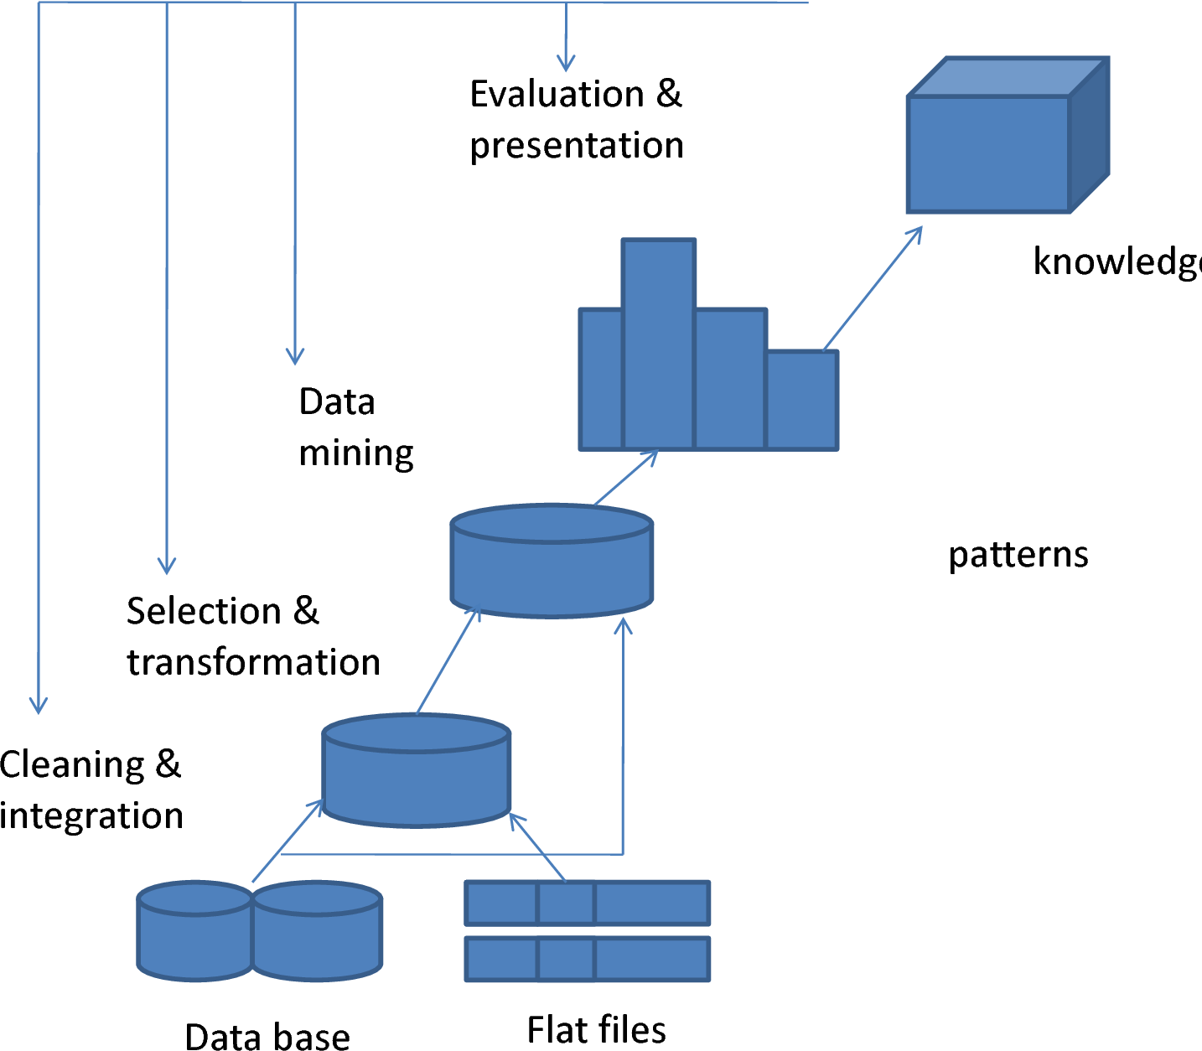

Algorithm Used: Clustering
→ Unsupervised Learning (no target variable)
K-Means Clustering
Divides data into K number of clusters
- Iteratively updates cluster centers (centroids)
- Uses distance (Euclidean) to group similar data
- Fast and efficient for large datasets
Hierarchical Clustering (Agglomerative)
- Builds a tree structure (dendrogram)
- Starts with each data point as a separate cluster
- Merges closest clusters step by step
- No need to specify clusters initially (can decide later using dendrogram)

These Algorithms Are Used:
No predefined labels available
Automatically groups similar countries
Helps identify development levels

CLUSTERING
Clusters (Result of Clustering)
A cluster is a group of countries with similar characteristics
Countries inside the same cluster are more similar to each other
→ Based on income, health, life expectancy, etc.
Countries in different clusters are very different

Cluster 1 - Underdeveloped Countries
Low income
High child mortality
Low life expectancy
Need urgent support
Cluster 2 – Developing Countries
Moderate income
(medium) health conditions
Need growth and development support
Cluster 3 – Developed Countries
High income
Low child mortality
High life expectancy
less priority for funding

VISUALIZATION


Used plots like: → PCA scatter plot
→ Dendrogram
→ Elbow graph
Helps to: → See how countries are grouped
→ Identify separation between clusters
Different colors represent different clusters

INSIGHTS
- Clear separation of countries into 3 development levels
- High income countries have:
→ Low child mortality
→ High life expectancy
- Poor countries show:
→ High child mortality
→ Low life expectancy
- Strong relationship between:
→ Economy and health
- Dataset shows global inequality

CONCLUSION
- The dataset was successfully analyzed using clustering techniques
- Countries were grouped into 3 clusters based on:
→ Economic
→ Health
→ Social indicators
- The clusters represent:
→ Underdeveloped
→ Developing
→ Developed countries
- Feature scaling and proper preprocessing improved the accuracy of clustering
- Visualization techniques like PCA and dendrogram helped in understanding the clusters clearly
- The analysis shows a clear gap in development levels across countries

